Steps to work with conflicts

>> Opening of readme in remote and update bus.java in local

* On 26th April, dev branch was created for mmt
* On 27th April, new update in bus depending on the UI:

1. Git pull origin dev
2. Update bus



1. Update Readme.md file .......................results new update to remote repo
2. Mvn clean compile
3. Mvn clean package
4. Mvn spring-boot:run
5. <http://localhost/bus>
6. Git add –all
7. Git commit –m “bus features”
8. Git push origin dev ........................results error

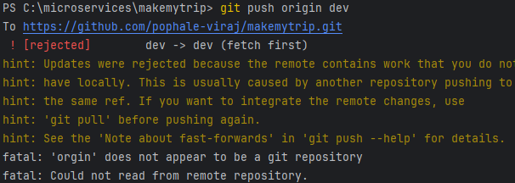

1. Git pull origin dev
2. Git push origin dev –f

* Creates bus features in remote repository along with existing readme.md

>> Update trains file in local and remote

* Update trains.java in github



* Update trains.java in local



* Prepare the local for upload to remote:

1. Mvn fine
2. Git add, commit fine
3. Git push origin dev .................results error



1. Git pull origin dev

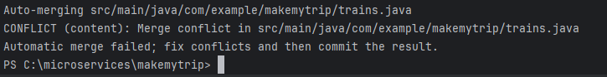

1. Update the file which is required and perform operations of mvn,git all of them
2. Git push orgin dev –f ...............this will pass local manually pdated code to remote and **overwrite the code**
3. **Below was not taken care for merging**



>> Updating the feature branch

* Create a pull into local dev branch
* Add changes to hotels.java as a developer4



* Checkout feature/xyz branch and add new lines to code

1. Git checkout –b feature/xyz
2. Update the hotels.java again
3. Mvn clean compile, package
4. Git add, commit
5. Git push origin feature/xyz

* Create a pull request in github .........................displays error

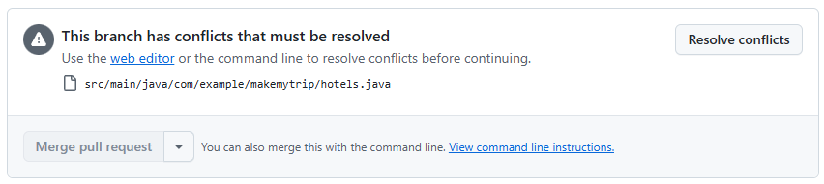

* Try Resolve conflicts
* Then do the changes in local repo to manage merge conflicts

1. Git branch ...................displays feature/xyz
2. Git pull origin dev ....creates dev pull and show same error like github
3. Mvn clean compile, package
4. Git status .........displays modified changes pending commit
5. Git add, commit
6. Git push origin feature/xyz –f

* Check status quo for PR(40/30)

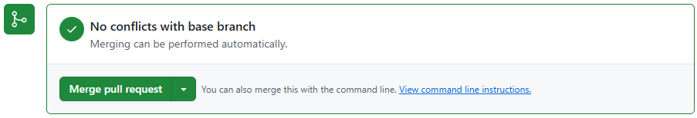

* Merge dev in all other branches